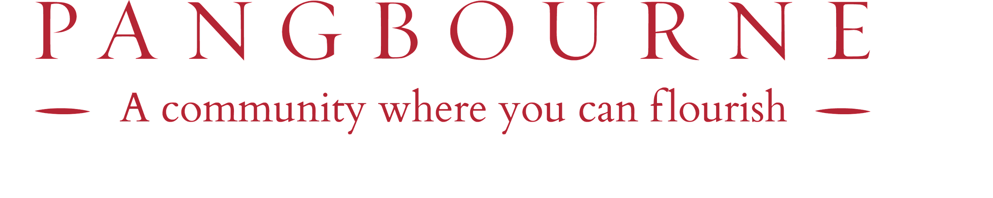

**PANGBOURNE COLLEGE AWARD APPLICATION FOR SEPTEMBER 2025**

# Academic, Sport, Design Technology, Art or Drama

**PLEASE NOTE:** Candidates need to be registered for entry in order to apply.

|  |  |
| --- | --- |
| Name of candidate |  |
| Date of birth |  |
| Current School |  |
| Current School address |  |
| Current School email |  |
| Name of Head |  |

I wish my child to be entered as a candidate for the following award (in the event of an award being offered, we undertake to withdraw from any other scholarship negotiation):

Please indicate ONE award only by ticking the box next to the appropriate subject. If you are applying for an Academic Scholarship, it is possible to apply for ONE other award also. All Year 7 candidates will be automatically assessed for an Academic Scholarship as part of the entrance assessment, an application is not required. Sixth Form candidates will be awarded an Academic Scholarship based on their GCSE results, an application is not required.

|  |  |  |  |  |
| --- | --- | --- | --- | --- |
| Year 7 |  | Sport | Art & Design | Drama |

|  |  |  |  |  |
| --- | --- | --- | --- | --- |
| Year 9 | Academic | Sport | Art | Drama |
| Lower Sixth |  | Sport | Art | Drama |

Signature: (Parent/Guardian) ……………………………………………………………………………………………………

Date: ……………………………………………………………………………………………………………………………..

Please return this form by the published closing date to: The Head of Admissions, Pangbourne College, Pangbourne, Reading, Berkshire, RG8 8LA or email [admissions@pangbourne.com](mailto:admissions@pangbourne.com). Late applications will not be considered.



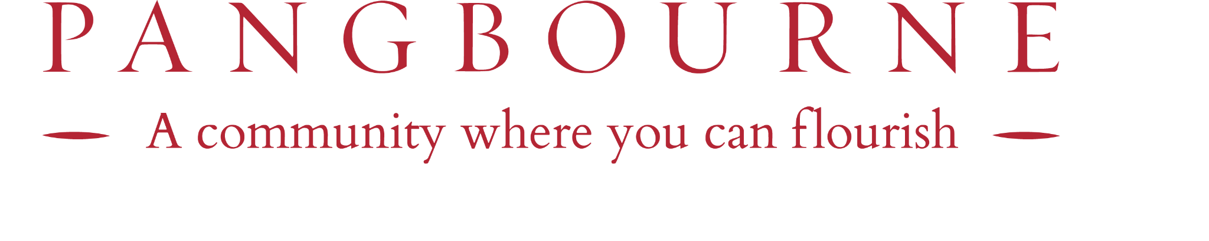

SCHOLARSHIP AWARD CALENDAR 2024

|  |  |  |
| --- | --- | --- |
| **YEAR 7 SCHOLARSHIP** | **APPLICATION CLOSING DATE** | **SCHOLARSHIP ASSESSMENT DATE** |
| Academic | No application required | Awarded for potential high performance shown during the entrance assessment. |
| Art & Design | 29 November 2024 | 28 January 2025 |
| Drama | 29 November 2024 | 28 January 2025 |
| Music | 29 November 2024 | 28 January 2025 |
| Sport | 18 October 2024 | 16 November 2024 - Assessment will take place for applicants on the same day as the entrance assessment. |
| **YEAR 9 SCHOLARSHIP** | **APPLICATION CLOSING DATE** | **SCHOLARSHIP ASSESSMENT DATE** |
| Academic | 29 November 2024 | 24  February 2025 |
| Art | 29 November 2024 | 28  January 2025 |
| Drama | 30  September 2024 | 18  November 2024 |
| Music | 30  September 2024 | 19  November 2024 |
| Sport | 30  September 2024 | 7  November 2024 |

# **Please note:** Lower Sixth Art, Drama, Music and Sport Scholarship applications are considered and assessed by individual arrangement.